CARTOGRAPHY AND CHILDREN. DESIGNING A MULTIMEDIA EDUCATIONAL TOOL.

Myron Myridis, myridis@topo.auth.gr
Anastasia Christodoulou, anastasia.christodoulou@gmail.com
Eleni Kalyva, kalyva@gmail.com
Nikolaos Karanikolas, karanik@auth.gr
Peristera Lafazani, lafazani@topo.auth.gr

Aristotle University of Thessaloniki
Department of Cadastre, Photogrammetry and Cartography
P.O. Box 439, 54124 Thessaloniki
Τel. +30231 996133, fax +30231 996415

Abstract
Map constitutes an important communication tool for the first contact of a child with the environment, as it forms the child’s perception about the world and shows the territorial correlation between the territorial units and their real area.
All researchers agree that children in a young age (beginning of primary school) are able to understand maps, thus the study of children’s performance in reading and using maps is very interesting for cartographical educators. Very important for them is to understand how young children comprehend subjects like spatial representation, scale, orientation, map symbolization, topographic and thematic maps, etc.
For example the understanding of scale, that prerequisites the perception of spatial correlations between the map and the real world and the ability to use a coordinate system in “reading” a map, is the key to understand a map properly. Also, the presence of graticule in a map helps the children to understand the spatial information and the exact position of a point.
Teaching with multimedia creates a new prospect in the process of learning. Multimedia provides structured information which is constantly updated and they can be transmitted easily and fast all over the world. For this paper we created an audiovisual program – application, that includes videos that have been created in Macromedia Flash, and it helps in the understanding of various cartographic terms. The videos’ aim is to explain in an easy way basic terms, with the use of figures that children are familiar with.
Key words: cartography and children, multimedia tool

Introduction
The role of cartographic education in our era is significant, as most of the sciences are increasingly occupied - directly or indirectly - with the concept of space and as a result there is an intense demand on mapping natural and human phenomena.
Maps in general, are considered to be essential communication tools in the educational process, as they help the students to achieve some basic knowledge. Part of this knowledge is their indirect contact with the environment-either from a geophysical aspect, or as a field where human activities take place, the understanding of the interdependence between man and environment or between human groups and the environment and also the growth of an inquiring mind.
When students "read" a map, they should be able to orientate and locate themselves properly, to use the scale for measuring distances or even to be able to design. Moreover, a map contains encoded information for the ground structure, for economic, social, demographic and other phenomena. It also represents natural, biological and social phenomena and connects the reasons for their appearance and their results. Therefore a map's proper "reading" helps a student achieve a higher level of knowledge.
Students, also learn to be more methodical in terms of interpreting geographic knowledge and thus knowledge in general. When "reading" maps they learn to recognize and classify the particularities and the complexity of different geographic phenomena. Finally, a map provides causes for analysis, composition, comparison, verification of a hypothesis and the export of conclusions. Therefore it contributes in the creative thinking of students. Consequently, the importance of cartographic education in the teaching process is unquestionable.
Maps in their traditional form and with guidance from the instructors, serve in a satisfactory degree this purpose. However, the development of technology and the constant increase of the use of computers during the past years, concern a wide variety of topics and applications in all faculties. These applications are used in the field of education and in the field of Cartography too.
Multimedia
Teaching with multimedia creates a new prospect in the process of learning, in all education levels. In a lot of countries during the past years there is a growth and development of these new teaching methods, as the advantages of the use of multimedia are plenty.
Multimedia provides structured information which is constantly updated and they can be transmitted easily and fast all over the world. Also, they provide attractive ways of presentating, transferring and exchanging data. More specifically, they provide dynamic high quality information such as video and sound and they require the use of all senses in the learning procedure, and especially the use if sight and hearing. They also provide the potential of investigating an effect of different parameters of a system with the help of programs of adjustment and simulation and finally, they contribute in the development of flexibility, adaptability and interaction.
Therefore, multimedia change the role of a student, providing a more flexible rhythm in learning, maintaining the activity and the attendance in the classroom in high levels, providing a form of individuality in the education process and also suggesting a new way of controlling the rhythm in learning. Consequently, teaching with multimedia provides a high level teaching environment, with high levels of efficiency that contributes to a more effective way of learning.
A necessary requirement for the reliable and constructive use of multimedia in schools is that the multimedia tools should have a content that is highly relevant to the taught subject and that they should fit with the learning environment. Of course, the role of the instructor in multimedia teaching is very important for their proper and effective use, as multimedia tools are only meant to support the teaching process and not to replace the instructor. This, on the other hand, also indicates the necessity of the instructors' proper training on these new multimedia tools, so that their advantages are fully understood in order to be used in an effective way.
In Greece, contrary to other countries, there is lack of knowledge from the instructors' side, when it comes to multimedia tools, lack of technical equipment for such type of applications in schools and also lack of such multimedia applications. When it comes to Cartography, things are even worse, as the lack of proper cartographic education and culture in our country, is reflected in the field of education not only from the instructors' lack of knowledge, but also from the absence of visual aids. Therefore, it is also necessary for the instructors to redefine their way of thinking and take into consideration the new potentials in teaching methods that are provided by the development of technology, and also, to be more informed in subjects having to do with Cartography, as well as in subjects having to do with the perception of children on maps.
The perception of maps
Briefly, some of the problems that children have when they "read" a map are the correlation between map and reality, the representation of the land under some scale, the coordinates and also the symbols of a map. At the same time, children of smaller ages are confused when they try to find the way, as they can't orientate themselves properly.
The comprehension of maps is developing at the same time with the growth of a child's perception, which also from the age but is also a result of each individual's stimuli and experiences. Therefore, each age should be treated in a different way when teaching Cartography.
Concisely, cognitive development forms four stages, according to the theory of Piaget: sensori – motor stage (from birth up to 2 years), pre-operational stage (from 2 to 7 years), concrete operational stage (from 7 to 11 years) and formal operational stage (from 11 to 13 years).
The pre-operational stage is mainly characterized by the use of semiotic systems to stand for objects or events. Such semiotic systems are language, gestures, objects and mental images. A child at this age may use the word home, or a drawing to indicate it’s home. Also, at this age, a child can't see someone else's viewpoint so this stage can be described as egocentric, as children perceive and interpret the world only in terms of themselves.
In concrete operational stage children have a more combinational way of thinking. They can classify cartographic symbols into points, lines and areas and understand that a line for example can represent a boundary. They can also use a reference coordinate system in order to locate an object. Moreover, they can orientate themselves properly and they can realize that a distance from a point A to a point B on a map is the same distance from point B to point A.
In formal operational stage, thought becomes more abstract, logical and hypothetical. In this stage children can acquire information from a map and evaluate them. They can also perceive how map projections work, and use a simple GIS function.
Apart from the age factor, the social and family environment and the child's own intelligence, are also very important factors in the development of a child's perception.
Multimedia tool (application)
Based on everything mentioned above, an application which is a proposal for the teaching of basic cartographic terms in students of primary school was created. It is an audiovisual digital application, which was created in a Macromedia Flash environment and it can help the instructor in the educational process. The aim of this application is not to replace the instructor, but to support the teaching process.
The potentials provided by this application are plenty, as the use of picture and sound helps in an easier comprehension of cartographic terms. Computers can dynamically simulate the potentials of other means and moreover use means that actually do not exist. Consequently such an application is suitable tool for the teaching of Cartography, where some terms are hard to be fully comprehended, for example the bas-relief, the contour lines and the way they are related. Since the application is more direct than a text and definitely more attractive for the user (particularly when the users are children), its use in the educational process will make the learning process more pleasant and as a result easier.
In the following paragraphs, there is a more extend report on the difficulties that children have when it comes to maps, and also shows the ways in which the multimedia application tries to explain some basic cartographical terms.
The application consists of a basic menu (Figure 1) where the user can select the subject that he wants, by clicking on it with the mouse. The subjects are : Globe and Ellipsoid, Meridians and Parallels, Graticule, Coordinates, Map Scale, Graphic (bar)Scale, Projections, Distortions, Generalization: Simplification, Generalization: Selection, Contour Lines , View from above, Map Contents. There is also an Exit choice which ends the application.

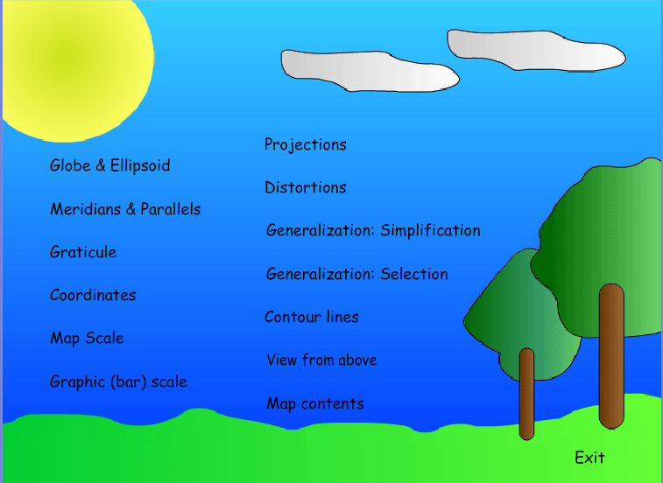

Figure 1: Initial Menu
Children at a young age understand that pictures are a representation of the real world. This is obvious from their drawings where they show their own perception of the world. Thus, they know that maps also are a representation of reality but with a view from above. However, most children at a younger age when trying to paint an area with a view from above have difficulties in omitting some details of the objects they paint. These details are characteristic for the nature of the objects, such as the windows and the door of a house, which normally should not be shown in map, as in a map there are only ground plans (Wiegand 2006). The “View from above” choice, shows a video, where a 3D model house is shown from different angles and ends in its position on a map (Figure 2).
Like previously mentioned, children understand that a map represents space information and consequently a map can be used for the finding of the way in an area. However, when they use a map to find the way, they have some problems, particularly when the map is not orientated to the user’s point of view (Blades and Spencer, 1990). This happens because students of younger age are confused when they try to see from another viewpoint and also because students do not come in direct contact with the real world to acquire experience from praxis.

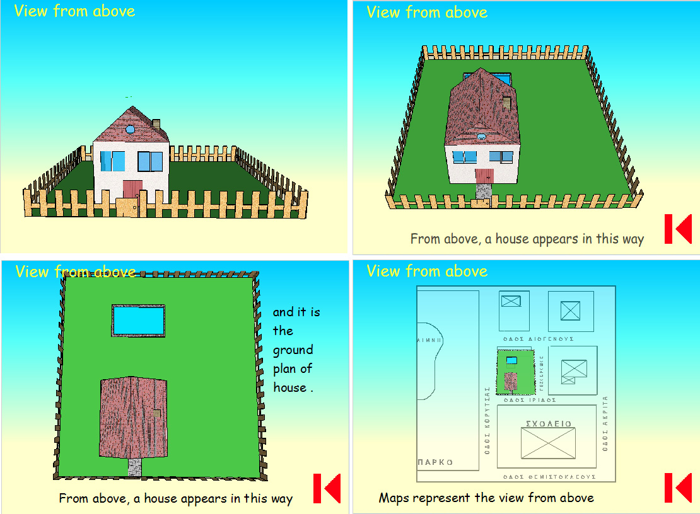

Figure 2: View from above
A very important fact for the better understanding of maps is also the understanding of scale. Children have an elementary perception of scale and size at a young age. This is obvious from their drawings: for example they draw adults as bigger figures. Consequently they understand that maps are a representation of reality under scale and understand scale, in an abstract way though. But when it comes to reading maps, and decoding all the map information, a clear and more specific understanding of scale is needed. The “Map Scale” choice shows a video where cartoon figures are used to show how scale works (Figure 3). The “Graphic (bar) Scale” explains how it is used on a map, to measure distances.
Very often, there are misapprehensions when children see small scale maps, where certain elements are omitted due to the generalisation. For example, in a small scale map where only the capitals of the countries are shown, children believe that there are no other cities in these countries (Sandford, 1972). Therefore, it is important for the children to understand that big scale maps contain more detail and information than small scale maps. A lot of detail is lost at the scale down of a map, so when there is a scaling down, there is a choice of which information will be shown. The “Generalization: Simplification” choice shows how details are lost because of the scaling down and the “Generalization: Selection” shows that when there is a scaling down, there has to be a choice of which information will be included in the smaller scale map and which not (Figure 4).
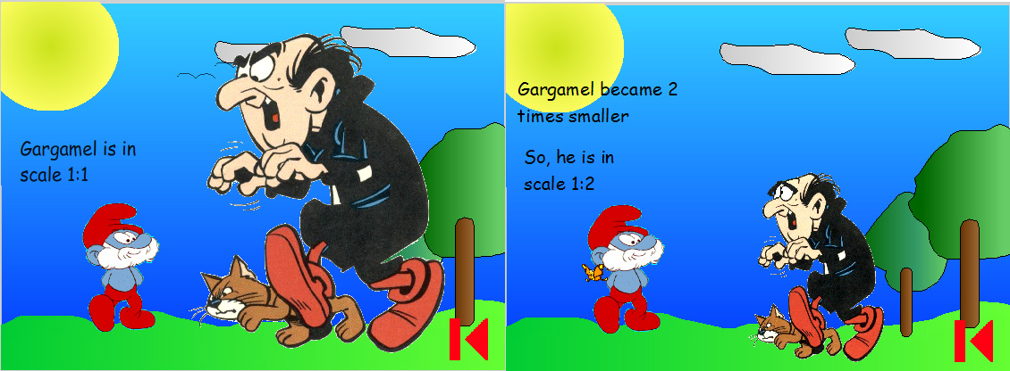

Figure 3: Map Scale
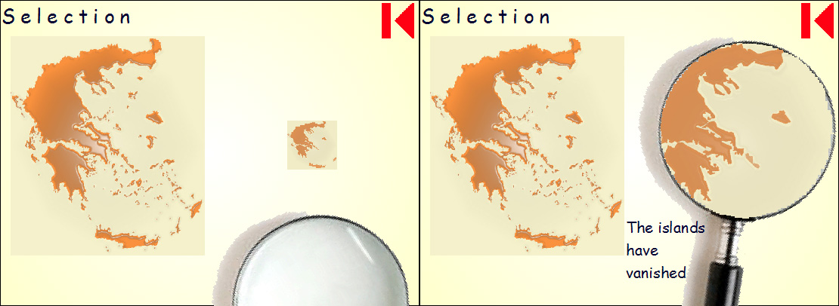

Figure 4: Generalization

Children learn that maps are a representation of the real world; therefore they should also become familiar with what the real world looks like. A lot of children have difficulties in understanding that the shape of the earth is spherical and not flat as they wonder why people that live in the southern hemisphere don't fall. The “Globe and Ellipsoid” choice shows earth in space where it’s real shape can fully be shown (Figure 5).
Finally one of the hardest things to understand, is the representation of the three dimensional ground in two dimensions with the use of contour lines. The “contour lines” choice shows a 3D model representation which ends up in two dimensions (Figure 6).

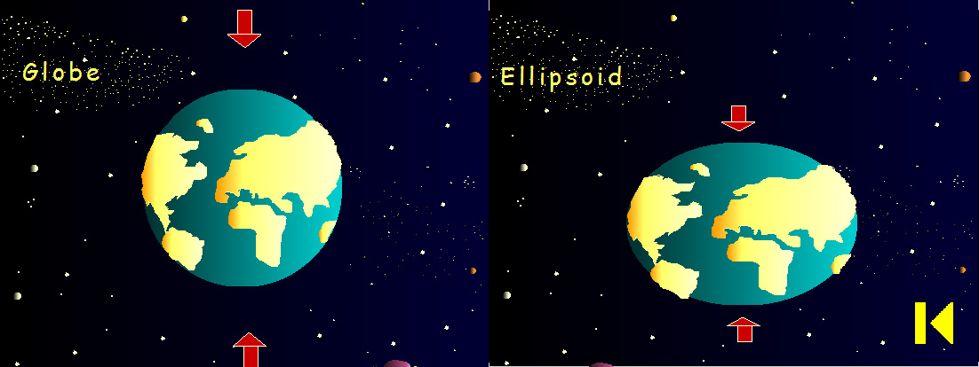

Figure 5: Globe and Ellipsoid
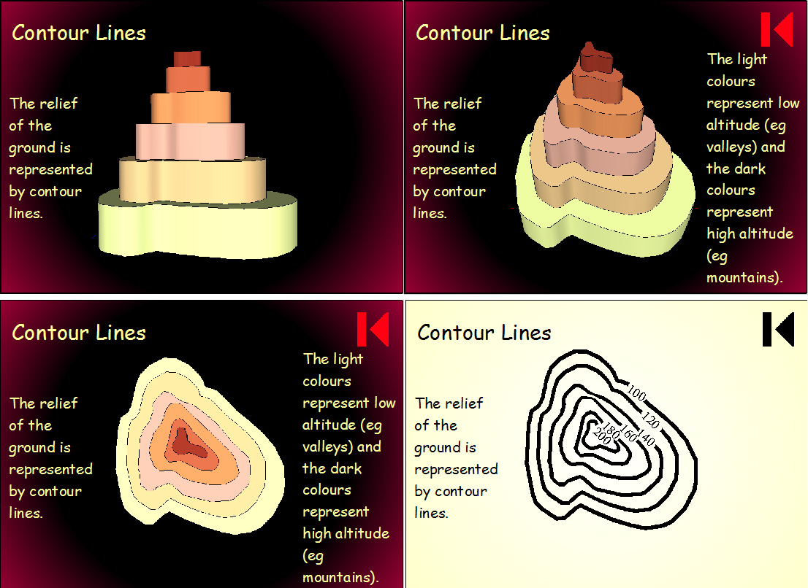

Figure 6: Contour lines
For the proper reading of a map, there is a graticule. The role of graticule could be easier understood if someone knows and understands what a reference coordinate system is. Therefore, the “Coordinates” choice tries to explain how a reference coordinate system works (Figure 7).

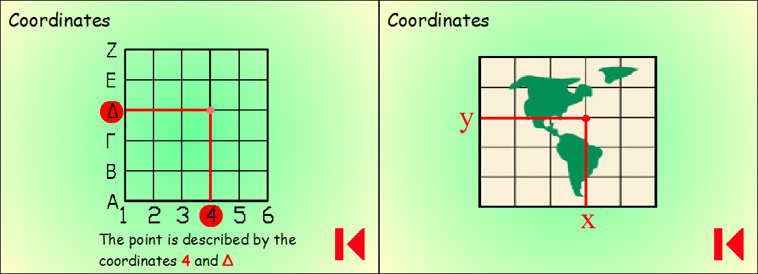

Figure 7: Coordinates

Conclusions
Map constitutes an important communication tool as it is the first “indirect” contact of a child with its environment, and it generally constitutes a basic tool in the educational process. Maps can be found in various courses in primary school, since pictures provide a more direct contact to the subject, and consequently learning becomes a more pleasant and easy process.
The development of technology and the continuously increasing use of computers over the past years, cover a wide variety of subjects and applications in all fields. Such type of applications can’t be absent from the field of education as well.
The digital application’s main aim is to provide a more pleasant teaching process and therefore could constitute a proper communication tool that results to the easier comprehension and learning of the various cartographic terms, due to the fact that it combines picture and sound. Thus, it is more attractive and more direct than a simple text and it resembles a game, which is more interesting for the majority of the young students.
Finally, proper cartographic education – provided in the first years of primary education - places “strong foundations” for the future cartographic education and generally promotes a wider cartographic knowledge and culture.
References:
- Wiegand P., 2006, ‘Learning and Teaching with Maps’, Routeledge, New York.
- Piaget, J. and Weil, A. (1951) ‘The development in children of the idea of homeland and of relations with other countries’, Institute of Social Science Bulletin.
- Piaget, J. And Inhelder, B. (1956) ‘The child's Conception of Space’, London : Routledge.
- Blades, M. and Spencer, C.P., (1990), ‘The development of 3-6 years old’s map using ability: the relative importance of landmarks and map alignment’, Journal of Genetic Psychology.
- Sandford, H.A., (1972), ‘Perceptual Problems’ in N. Graves (ed.), New Movements in the Teaching and Learning of Geography, London: Temple Smith.
- Michaelidou E., B. Nakos and V. Filippakopoulou, (1997), ‘A Study on the Ability of Children in Understanding the Fundamental Elements of Reality Presented on Maps’, Proceedings of 18th International Cartographic Conference, Stokholm, Sweden.
- Nakos B. and V. Filippakopoulou, (1998), ‘The Cartographic Component in the Didactic of Geography. A Critical Review of the Maps Included in the Geography Textbook of the First Class of the Secondary School’, Proceedings of the 1st National Conference on The Didactic of Physical Sciences and the Implementation of new Technologies in Education, Thessaloniki, Greece.
- Robinson A., Morrison J., Muehrcke P., Kimerling A., Guptill S., 1995, ‘Elements of Cartography’, John Wiley & Sons, New York.
- Livieratos E., (1980), ‘Thematic Cartography’, Thessaloniki, Greece. (Greek edition).
- Livieratos E., (1998), ‘General Cartography and Introduction in Thematic Cartography’, ZITI, Thessaloniki, Greece (Greek edition).
- Papadopoulou M. (2000), ‘Fundamentals of Cartography’, Thessaloniki, Greece. (Greek edition)
- www.columbia.edu
- www.csd.uoc.gr
- www.epp.teiher.gr
- www.et.teiath.gr

